Methodical instructions to the laboratory work №1
DESIGNING THE TEMPORAL CHARACTERISTICS OF COMPUTER SYSTEMS AND NETWORKS
Purpose of the work: To develop and realize in the form of program the mathematical model of the temporal characteristics of the multiprocessor system or network computation.

General terms
Under the complexity of algorithms the quantity of the calculable work required for realization of algorithm on the computer system is meant. The complexity of algorithm is evaluated by the quantity of operations that are executed with the purpose of processing, input and output of information, in the process of solving the task.
The information related to the task is divided into the program and data: the latter include basic data, intermediate quantities and final results. Data can be located both in operative, and in the external memory.
Operative and external memories differ in access methods and speed descriptions. The expenditures of time for addressing the operative memory are proportional to the quantity of read or written information.
The expenditures of time for addressing the external memory are mainly determined by time of data area search and in less degree are relied on the quantity of information transferred. Therefore for reduction of time expenditures for an exchange of the information with the external memory for every appeal is expedient to pass a big amount of information.
Information which is stored in the external memory divides into files - well-organized ser of data processed by one general for these data method. The operations of addressing the external memory are usually considered as operations of input-output.
Complexity of calculations is estimated by the labour input, which in turn is determined by the quantity of operations, executable with the purpose of processing, input and output of information, in the process of solving the task. The complexity of algorithm is a probabilistic magnitude, as the duration and the number of executable operators at various basic data can be different. Therefore the complete description of labour input supposes the description of the operations, executed during one realization of algorithm, by accidental magnitudes.
Application of static methods of operations quantity determination is a difficult and long process, therefore the labour input of algorithms is usually described by the methods of mathematical statistics, for example, by means of the mathematical description of the executable operations number.

The labour input of algorithm can be described by the following aggregate of parameters:
Q – the mean quantity of processor operations executable during one realization of algorithm;
N1 . . ., NH - mean time of accessing the file F₁ . . . F_{H;}
Q1 . . ., QH - the mean quantity of bytes, passed during one access to files F1 . . ., FH respectively.
The Q value characterizes the labour input of counting, and the values N1 . . ., NH ;Q1 _{. . ., QH} - labour input of the information input-output process; H - quantity of files.

At solving the tasks of computer systems’ analysis and synthesis there is a necessity in describing the properties of computational processes. At the research it’s expedient to present a computational process by the models, that carry the information only about process properties, the consideration of which is needed and possible at solving the tasks of computer systems analysis and synthesis. Taking into account the information about the labour input of algorithms it is possible to formulate the next requirements to the models.
A model must determine:
1) the passing order of the queries algorithms, stored in each file;
2) labour intensity of queries maintenance – the quantity of operations that must be executed by a processor at the maintenance of the request for the account, and quantity of input-output information characters;
3) it has to represent the computational processes as an accidental process realization.
The computational processes generated by a model must correspond to the real processes within the coincidence, at least, the mathematical expectations and the same name descriptions.
First two requirements determine the circle of information about computational processes, that have the biggest impact on the computer system’s functioning order.
The necessity of the third requirement is dictated by the effectiveness of probabilistic approach for the computational processes research. The chance factor, entered in a model, allows to generate the endless number of computational process realization. It is usual for algorithms performing processes.
The last requirement determines the minimum norm of the model "exactness". Taking into account these requirements the model of computational process is built. At the initial stage it is necessary to estimate the labour intensity of algorithms. As to the tasks of analysis of labour intensity let’s subdivide the operators into functional, branches and access to the files operators.
Functional operators set the aggregate of computational operations. Branches operators set the rules of the choice of one possible computational process’s development way. File access operators reflect the information exchange process with the peripheral devices.
As a rule, a few peripheral devices exist in the system and a few files are formed. Functional operators are called the basic operators. For estimation of algorithms labour intensity it is necessary to divide the number of operators into classes:
basic operators
S₀ = {Vai... Vam }
File access operators
S_{H} = {V^{h}_{βI}... V^{h}_{βI} }
where h = 1..., H - number of a file to which the appeal is carried out in V_{βI} operator; H - total number of files; m - total number of operators of the given type.
The set of operators and links between them is evidently shown by the algorithm graph, in which every arc (i, j) is marked by the probability of the Rij transition from the point V_{I} to the point V_{j} . As the computational process can not stop arbitrarily, except the ending point (k), then the transition to some algorithm graph’s point will happen with the probability 1. Taking that into account, for any point V_{I}(I=1,2..., k-1) a condition must be true
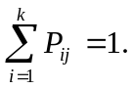
The Rij probabilities depend on the probabilities of condition fulfillment. This condition is checked by the i operator, with the purpose of the transition way choice. For example, let the operator i generate the transition to the operator j at the negative value of some variable x and to the operator 1 at the positive variable value. If it is known, that the magnitude x is evenly distributed in the (-1; +3) range, then with probability 0,25 its sign is negative and with probability 0,75 – it is positive. Thus, the transition to the operator j takes place with the Rij probability = 0,25 and transition to the operator 1 - with the Rij probability = 0,75.
For cycle operators the transition probability is determined by the quantity of cycles. For example, the cycle operator must be executed 9 times, in this case the probability of loop exit Rij = 0,1, and the probability Rij of the cycle implementation =0,9. If straight after the operator і the operator j is executed, Rij =1.

Example: The Scheme-algorithm is represented on the Pic.1.1. The matrix of the transitions probabilities of this algorithm is presented in the Table.1.1.

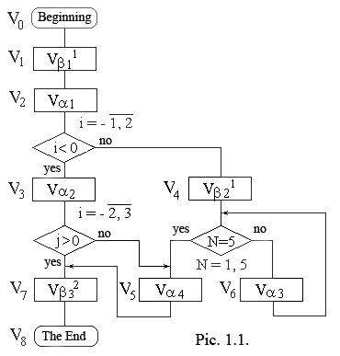

Table. 1.1
 | V1 | V2 | V3 | V4 | V5 | V6 | V7 | V8
V1 |  | 1
V2 |  |  | 0.25 | 0.75
V3 |  |  |  |  | 0.5 |  | 0.5
V4 |  |  |  |  | 0.2 | 0.8
V5 |  |  |  |  |  |  | 1
V6 |  |  |  |  | 0.2 | 0.8
V7 |  |  |  |  |  |  |  | 1

Let’s assume that n1 ..., nk-1 is the mean number of the addresses to the operators V₁, ... ,V_{k-1} for 1 execurion of algorithm; ki - number of operations making the i-th operator. In this case the descriptions of labour input can be calculated as follows:
The middle number of processor operations executed at one run of algorithm
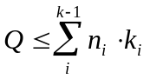 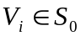 (1)
The middle number of addresses to the file Fh
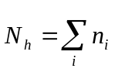, 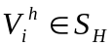 (2)

The middle information quantity, passed at one addressing to the file Fh
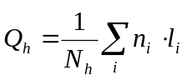 (h = 1 ..., H ) (3)
where li is the mean information quantity passed at the implementation of i operation.
In the expression (1), adding is performed for all points related to the basic operators, in expressions (2), (3) - for all point reflecting the addressing to the given file.
In most cases the probabilities of the Pkj transitions are permanent for the given algorithm and the transition to the next operator is determined only by distributing of the Pkj probability, i.e. the process of calculation is a marking process with k states S1 . . ., Sk, that correspond to the process staying in the points V₁ , . . . , V_{k} of the algorithm graph. The states S1 . . ., Sk-1 - are irrevocable (after some number of steps a process certainly abandons them), the state S – is absorbing (attaining it a process is halted). For simplification of denotations let’s assume that the initial state - S1. The order of the state changing is determined by the graph of algorithm, the arcs of which are marked by the probabilities of the Pij transitions. The noted algorithm’s graph is possible to consider as a marking chain. The mean number of n₁, . . . , n _{k-1} stays of marking process in the irrevocable states S1 . . ., Sk-1 is determined by the roots of the linear algebraic equations system:
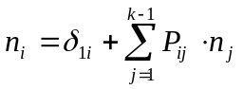 (i = 1, . . . ,k-1), (4)

where δ_{1i} – Kronecker’s symbol (δ_{ij} = 1 at i = j and δ_{ij} = 0 at i ≠ j).
Values of n1 . . ., nk-1 determine the results of the linear algebraic equations system (4), the canonical record of which looks like:
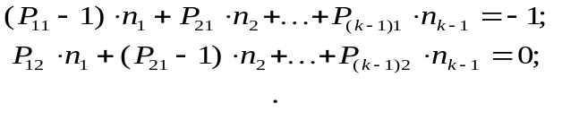
. . . . . . . . . . . . . . . . . . . . . . . . . . . . . . . . . . . . . . .
(5)
Forming the system (5) coefficients it is necessary to pay attention to the fact that the Pij coefficients are written down not in lines, but in columns, i.e., for example, on the place of the second element of the first line an element with an index 21 stands, and not the coefficient with the index 12 of the transitions matrix.
After the determining by the formulas (1), (2) and (3) the Q, Nh, Qh, values it is possible to define the middle labour intensity of the computation stage, on the basis of which the optimum internal performance estimation is carried out.
The middle labour intensity of the computation stage is determined by the formula:
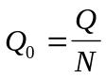 (6)
where N – is the sum of the addresses mean number ni to the basic operators (S₀), i.e.
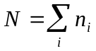, (7)

Task and the initial data for the laboratory work №1

Initial data
For the dimension reduction of the linear algebraic equations system it is expedient to unite the sequential chains of operators in one generalized operator. After that, the matrix of transition probabilities is built (MTP).

Before the solution of the linear algebraic equations system the research of the given system is performed. The purpose of the research is the construction of conditionality estimation. At the normal conditionality estimation the system of linear algebraic equations is solved. After the initial data (which is determined by the variants) input, the basic indexes of algorithm’s labour intensity and the mean labour intensity of the computation stage are evaluated.
Task
Using the given graph-scheme of algorithm (on the coordination with the teacher), build the matrix of transitions probabilities.
Define the basic parameters of algorithm’s labour intensity: a) the middle number of operations at one running of algorithm; b) the middle number of addresses to each of the files; c) the middle number of information, passed at one addressing to a file; d) the middle labour intensity of the computation stage.

